Techno Machine Tools
Survey no:126/A/1, DOOR NO: 4-132-9/A/2, Gandimaisamma X Road,
Medchal Malkajgeri,Hyderabad-500043.Telangana, India.

(Machine tool manufacturers)

T.SIVARAMAKRISHNA
ME., MBA.
--------------------------------------------------------------------------------------------------------------------------------------

TMT/Hebeleten Projects/S0233/2025 25.04.2025

To,
Kiran Chittimala
Hebeleten Projects
Mobile : +91-9985994577
Email : hebeleten@gmail.com

Dear Sir,

Sub: SUPPLY OF ROLL FORMING MACHINES FOR GUARD RAIL
Thank you very much for your enquiry regarding your requirement of roll forming machine mainly for Guard rail forming. We are glad to inform you that we would be in a position to supply you the required equipment in five different machines for five sections. Given below are the required specifications and description of the machines and our terms and conditions.

MILL: 475 mm WIDE ROLL FORMING MILL

LIST OF MACHINERY

1) De Coiler 7 MT Capacity

3) Sheet Leveler cum feeder
5) Online gang Punching Press
6) Punching Tool
7) 14 Station Roll Forming Machine
8) Delivery Hydraulic Cutting Unit
9) 16 Feet Runout Table
10) Electrical with PLC

MANUAL DE - COILER

Model : Single arm

Coil weight : 7 MT Max

Coil width : 475 MM

Oil bore : Dia 450 MM min, 550 MM max

Mandrel movement : Hydraulic

Back Tension :Caliper brake, Hydraulically adjusted

Construction : M. S. Fabricated.

Drive : 5 HP

SHEET LEVELER

Maximum sheet width that can be leveled : 475 MM

Maximum sheet thickness in MS that can be leveled : 3.15 MM

Minimum sheet thickness in MS that can be leveled : 0.72 MM
Total Drive : 7.5 HP (AC)

Speed of the machine : 0-15 meters/min

DESCRIPTION OF THE LEVELER UNIT

ENTRY GUIDE

The entry side of slitter head is by means of guide table; guide blocks along with guide rolls, which will be responsible for centering the leading ends of the sheet in to the first pass.

LEVER AND PINCHROLL

Number of rollers for leveling : 5 No’s

Number of pinch rollers : 2 Nos

Diameter of the roll : dia 75 mm

Load arrangement for leveler : MANUAL

Load arrangement for pinch rolls : MANUAL

Model : Crossed Beam

Drive : 7.5 HP – AC motor

The lever is with triangular roll attachment along with screw down along with differential load indication.. The pinch roll is allowed the strip to move to forward to entry guides.
PUNCHING PRESS AND SHEET FEEDER
Sheet feeder is an pinch roll unit and the drive is controlled with main motor connected with PLC for accurate punching of the holes at different intervals.
Punching unit is an hydraulic press operates with the help of PLC. The hole die in installed in the press.

MAIN - ROLL FORMING MACHINE
Maximum sheet width that can be formed : 475 MM
Maximum sheet thickness in MS that can be formed : 3.15 MM
Minimum sheet thickness in MS that can be formed : 0.5 MM
Roll shaft diameter : ɸ 80 MM
The vertical distance between shafts : 150 – 290 MM
The horizontal distance between shafts : 450 MM
Number of forming stations : 18 No’s
Drive (A C) : 30 HP For main mill only
Speed of the machine : 15 meters/min
Overall length of the machine : 9,700 mm
Over all width of the machine : 2000 mm
Overall height of the machine : 1100 mm
CUTOFF UNIT
Model of hydraulic press : 4 pillar model
Maximum tonnage : 100 MT
Table size : 900 x 450 mm
Day light : 550 mm
Cutting die set : cutoff tool

DESCRIPTION OF THE MACHINE
ROLL FORMING MACHINE
MAIN BASE
The main base is MS fabricated structure and adequately ribbed to minimize the distortion. It is accurately machined on top and bottom surfaces the threaded holes are made on the bed for positioning the stands.
ENTRY GUIDE
The entry side of the machine will be equipped with guide table and the guide wheels bar which will be responsible for centering the leading ends of the strip into the first pass.

MILL STANDS
The stands are mounted on the bed of the machine the line alignment can be easily done due to guide ways arranged on the bed of the machine. Each forming head consists of a fixed housing and sliding type out board housing. The mill stands will be arranged to locate shafts mounted on anti-friction bearings. For the top shafts the bearings are housed in the cartridge type bearing blocks. The bottom shaft bearings are located in the bored machined in the housings. The bottom arbors are fixed in position whereas the top arbors along with cartridge blocks could be raised or lowered in vertical guides machined in housings.
ROLL SHAFTS
The roll shafts will be manufactured from quality steel and will be keyed to locate tooling. The roll shafts are hardened and ground the close tolerances.
ROLL FORMING ROLLS
The raw material for the roll forming rolls is with EN31 grade.
RUNOUT TABLE
The run out table is a roller table with a drive. Provision for adjusting the height of the table is available.
DRIVE
The drive to the roll former will be by means of a main reduction gear box and individual gear boxes with top roll drive. The main drive will be provided by means of 30 HP/ AC motor along with A/C Drive. The speed of the roll former is variable. Hydraulic power motor 15 HP.
Total drive to the roll former is : 50 HP
De coiler : 5 HP
Sheet leveler : 7.5 HP
Main mill : 30 HP
Hydraulic power pack : 7.5 HP
PLC equipments is with UPS backup.

PRICE
- Price for the above list of machinery with punching die, cutting tool etc is
Rs 74,00,000/- ( Rupees Seventy Four Lakhs Only)
GENERAL TERMS & CONDITIONS:

- Price quoted per unit ex-work. Hyderabad.
- Following charges are additional to your account.
- Freight Charge : As actual to be borne by you.
- Excise : Extra As Applicable – 12.5%
- Sales Tax : Extra as applicable 14.5 or 2% against ‘C’ Form
- Packing charge : As actual to be borne by you.
- Insurance : As actual to be borne by you.
- Payment : 50% advance along with order balance before delivery but after inspection at our works.
- Delivery : with 50% advance 3 months from date of advance received
- Validity : One month from the date of submission.
- Inspection : Inspection at our works prior to dispatch.
- Warranty : The machine is warranted for a period of 12 months from the date of dispatch against any manufacturing defects/ faulty material or bad workmanship of any part or component but not against any kind of abnormal or improper use of machine. Defective part or component will be replaced or repaired free of cost. Electrical components are outside the scope of this warranty.
- Commissioning : Erection & commissioning done by you, but required technical support & guidance provide by us at additional cost.

NOTE:
- Oil is not in scope of our supply.
- Raw material for trial is to be arranged by you at your cost.

We are sure you will find our offer in line with your requirements. Please contact 9246221106 for further information required if any.

Thanking you and assuring you of our best services.

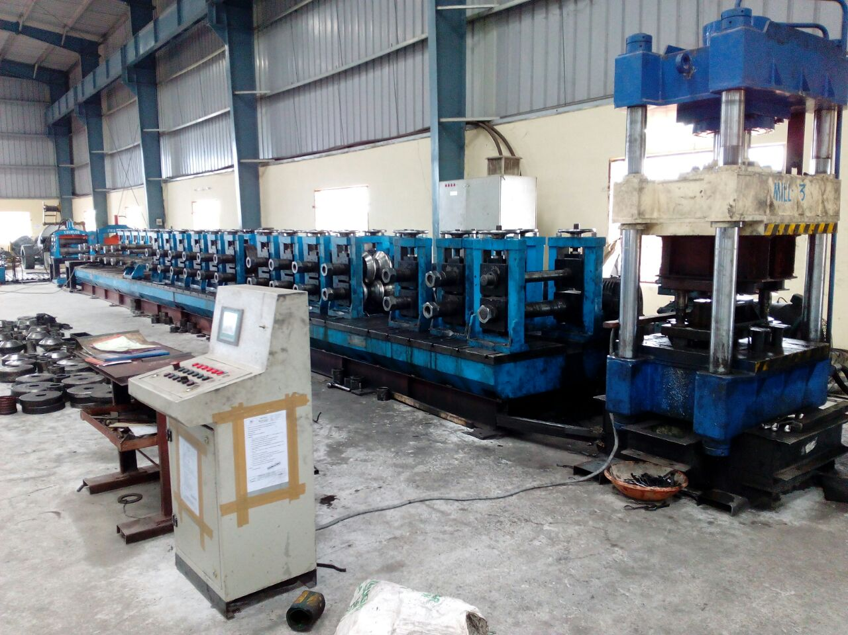

For TECHNO MACHINE TOOLS

(T. SIVARAMAKRISHNA)

